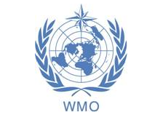

WMO GURME Training Course on

Air Quality Modeling for Latin American Cities Project

Mexico City

August 10-14, 2009

http://mce2.org/gurme.html

